Task on Argocd.
- Setup ARGO CD
Purpose: Argo CD is used for GitOps — automatically deploy applications to Kubernetes from Git.
Step 1: Create Argo CD namespace
kubectl create namespace argocd 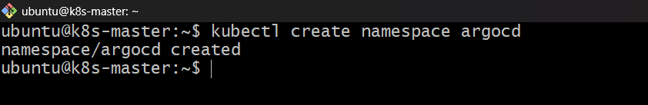
Step 2: Install Argo CD
kubectl apply -n argocd \
-f https://raw.githubusercontent.com/argoproj/argo-cd/stable/manifests/install.yaml 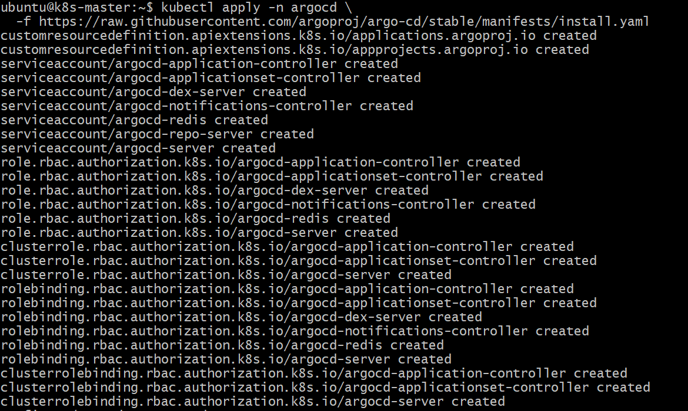

Step 3: Check Pods
kubectl get pods -n argocd
Wait until they are Running. 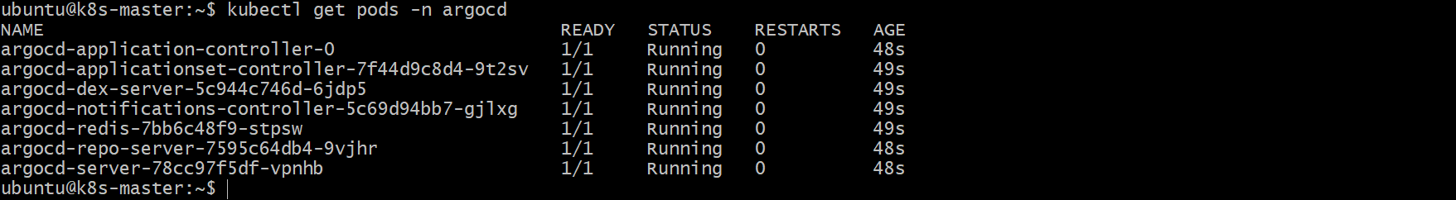
Step 4: Expose Argo CD
kubectl patch svc argocd-server -n argocd \
-p '{"spec":{"type":"LoadBalancer"}}'
Step 5: Get Load Balancer
kubectl get svc argocd-server -n argocd
Copy the EXTERNAL-IP.
Step 6: Get Admin Password
kubectl -n argocd get secret argocd-initial-admin-secret \
-o jsonpath="{.data.password}" | base64 -d
Login:
Username: admin
Password: <password>
Open the Load Balancer address in your browser.

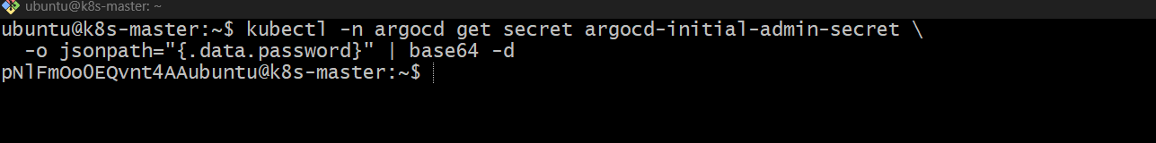

Run on your k8s-master:
kubectl -n argocd get svc 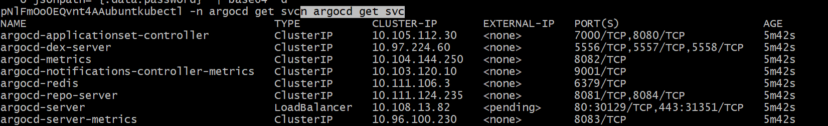

kubectl get nodes -o wide 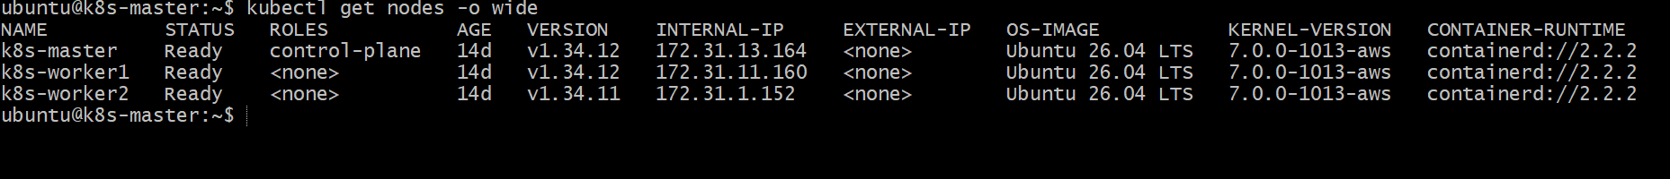
Then try:
https://100.24.121.132:31351
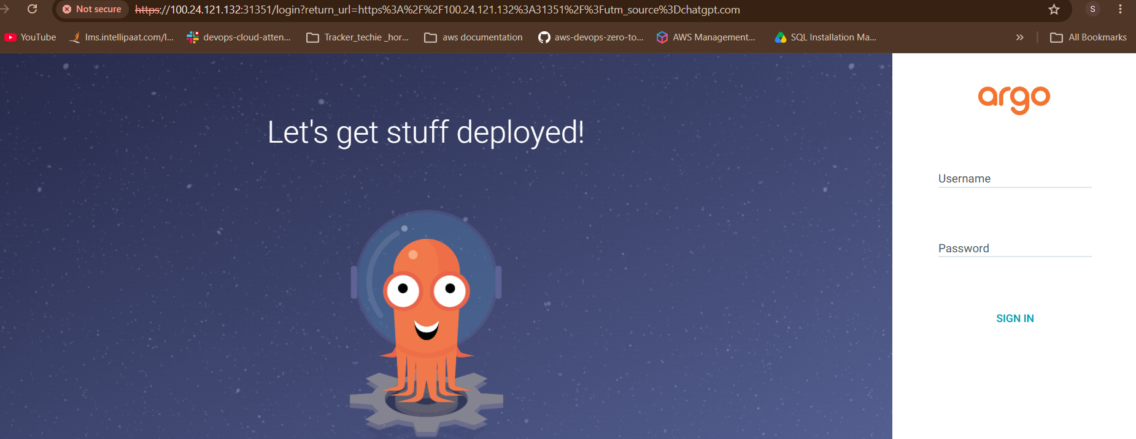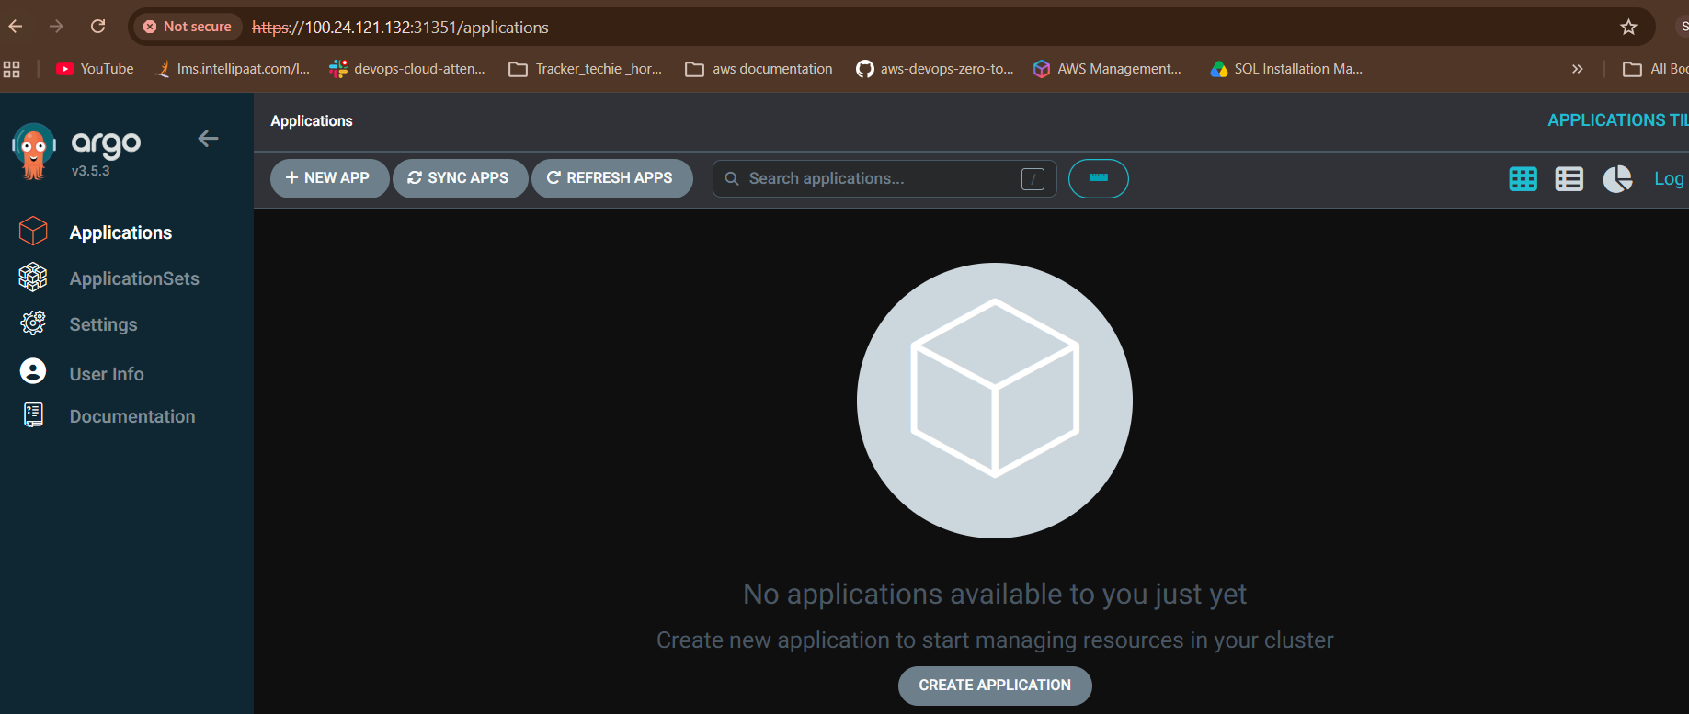

- Create Jenkins job for CI.
Purpose: Automatically build and test the application whenever code is pushed to Git.
Step 1: Open Jenkins
Open:
http://<JENKINS-IP>:8080
Step 2: Create Job
- Click New Item
- Enter name: my-ci-job
- Select Pipeline
- Click OK 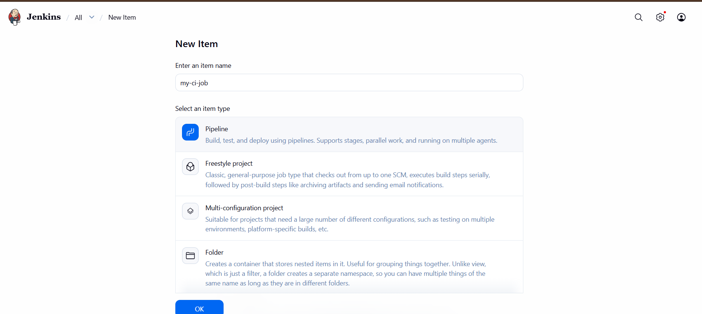
Step 3: Add Pipeline
Go to Pipeline → Definition:
Select:
pipeline {
agent any

stages {

stage('Checkout') {
steps {
git branch: 'main',
url: 'https://github.com/satishcloud00/myapp.git'
}
}

stage('Build') {
steps {
sh 'docker build -t myapp:latest .'
}
}

stage('Test') {
steps {
echo 'Running application tests...'
echo 'CI build and test completed successfully.'
}
}
}

post {
success {
echo 'CI Pipeline completed successfully!'
}

failure {
echo 'CI Pipeline failed!'
}
}
}
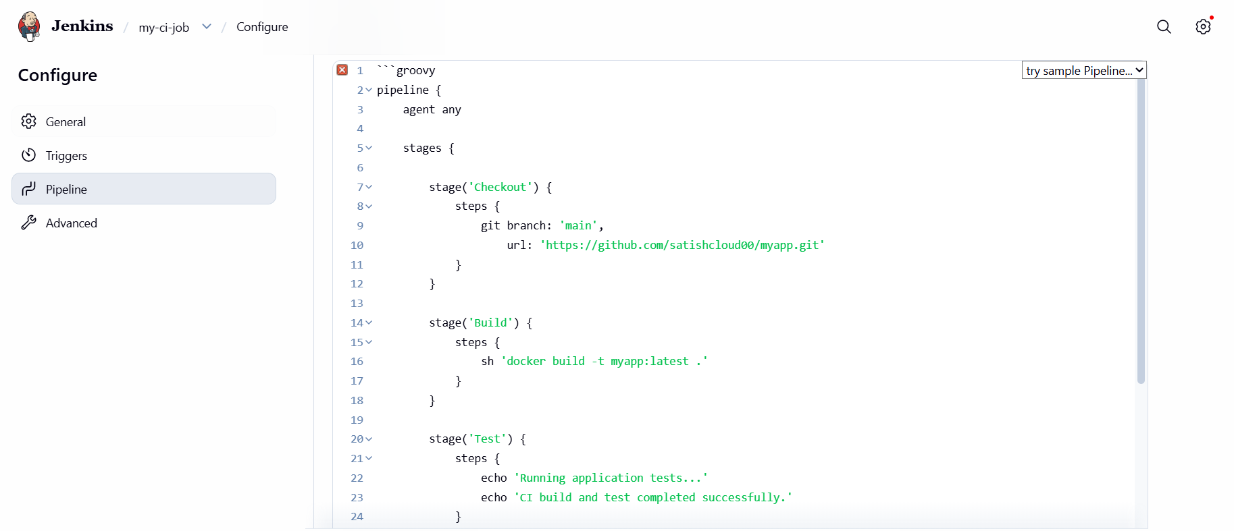
Step 4: Save & Run
Click:
Save → Build Now
Step 5: Check
Build #1 → SUCCESS 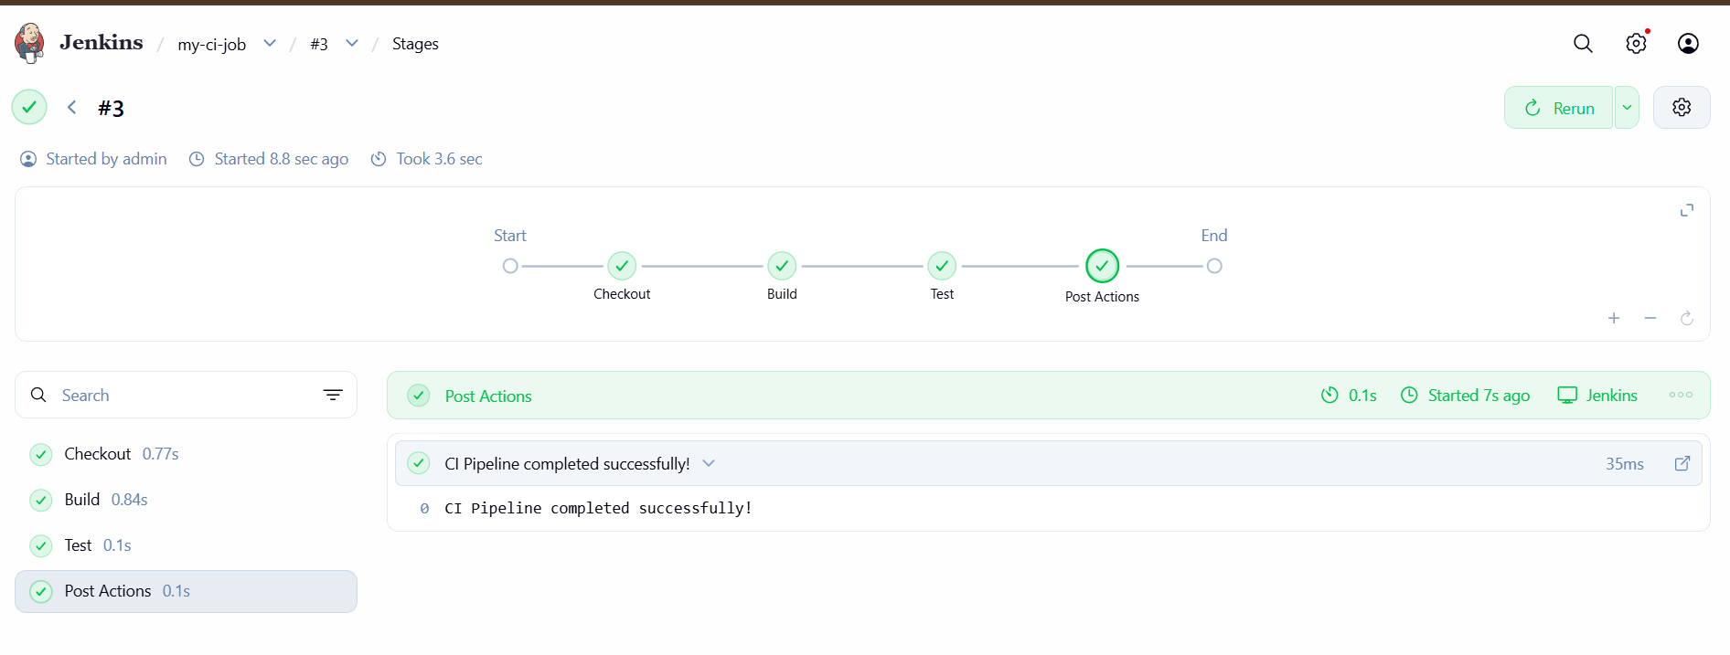
CI flow:
Developer → GitHub → Jenkins → Checkout → Build → Test

- Create Jenkins job to create docker image and build image.
Purpose: Jenkins automatically builds a Docker image from your application code.
Step 1: Create Jenkins Job
1. Jenkins → New Item
2. Name: docker-build
3. Select Pipeline
4. Click OK
Step 2: Add Pipeline
Go to Pipeline → Pipeline script:
pipeline {
agent any

stages {
stage('Checkout') {
steps {
git 'https://github.com/<username>/<repo>.git'
}
}

stage('Build Docker Image') {
steps {
sh 'docker build -t myapp:latest .'
}
}
}
}
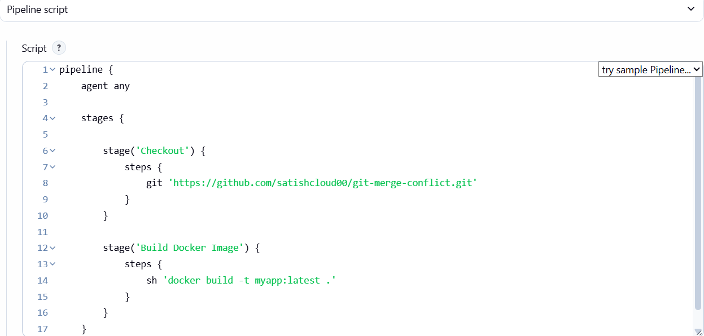
Replace:
<username>/<repo>

with your GitHub repository.
Step 3: Save and Build
Click:
Save → Build Now 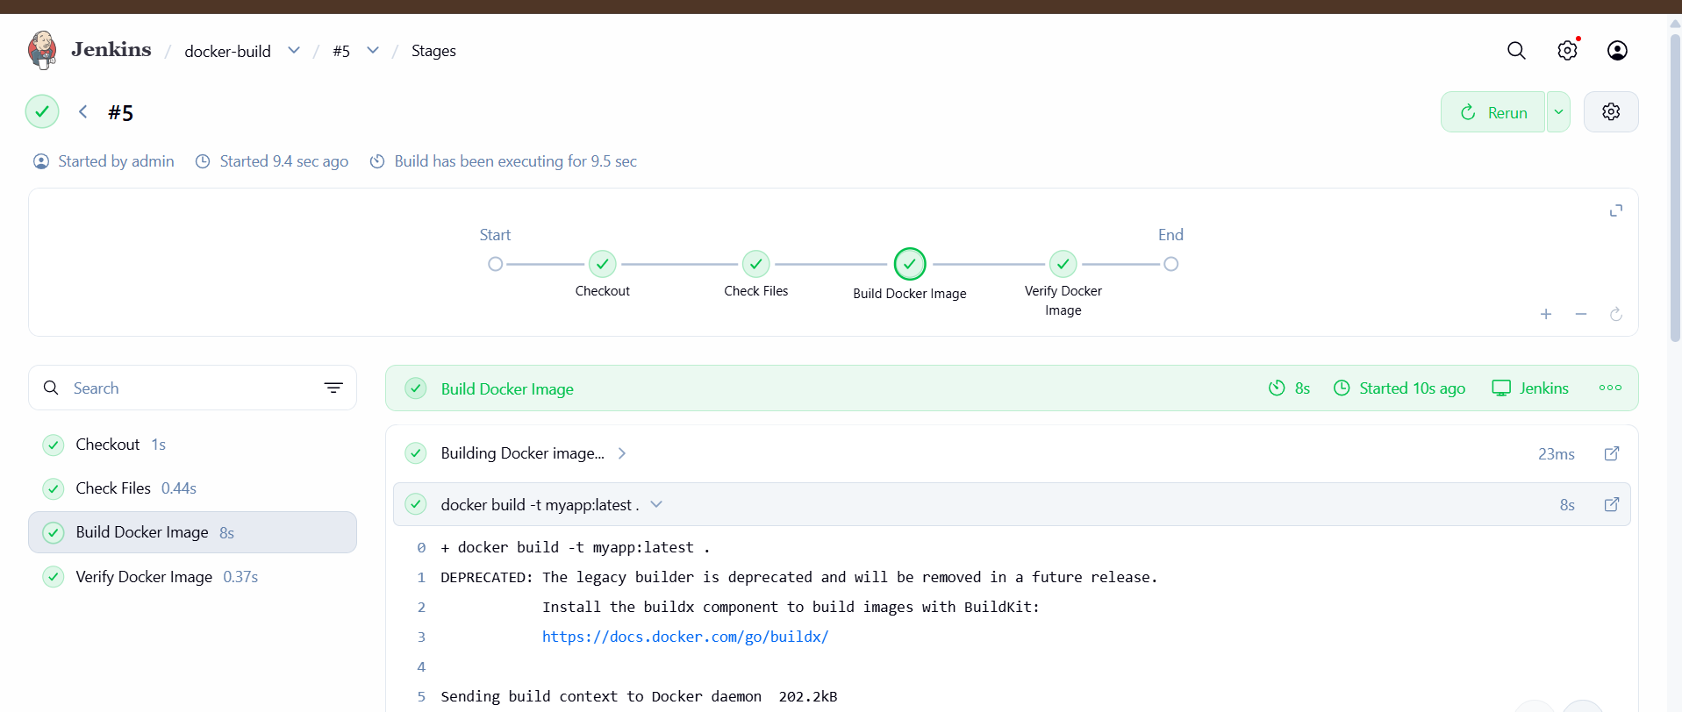

Step 4: Verify Docker Image
On the Jenkins server:
docker images
You should see:
myapp latest 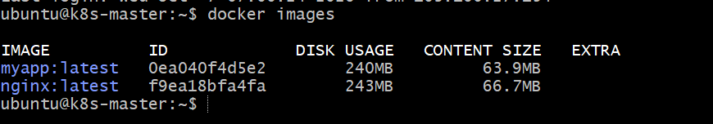

CI Flow
GitHub
↓
Jenkins
↓
Checkout Code
↓
docker build
↓
Docker Image

- Create ArgoCD job to deploy on ek8s cluster.
Purpose: Argo CD automatically deploys your Kubernetes application from Git to EKS.
Step 1: Create Kubernetes manifest
Create deployment.yaml:
apiVersion: apps/v1
kind: Deployment

metadata:
name: myapp

spec:
replicas: 2

selector:
matchLabels:
app: myapp

template:
metadata:
labels:
app: myapp

spec:
containers:
- name: myapp
image: nginx:latest
ports:
- containerPort: 80
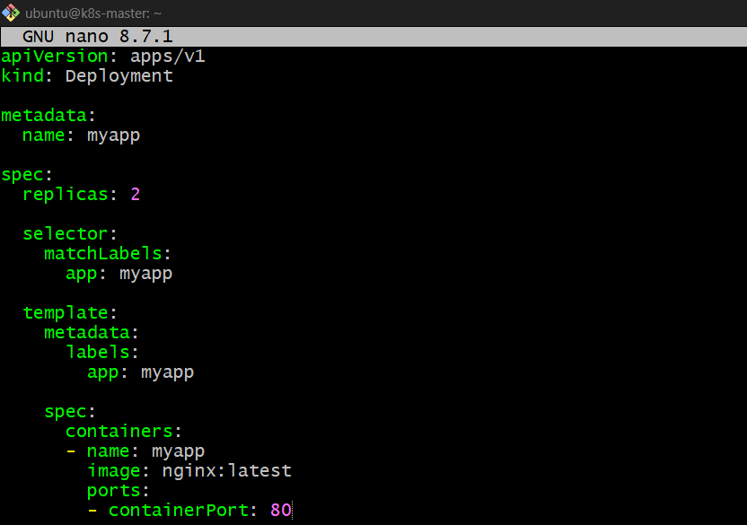
Push this file to GitHub.
Step 2: Create Argo CD Application
Watch my GitHub myapp repository and automatically deploy its Kubernetes manifests to my Kubernetes cluster."
kubectl apply -f - <<EOF
apiVersion: argoproj.io/v1alpha1
kind: Application
metadata:
name: myapp
namespace: argocd
spec:
project: default
source:
repoURL: https://github.com/satishcloud00/myapp.git
targetRevision: main
path: .
destination:
server: https://kubernetes.default.svc
namespace: default
syncPolicy:
automated:
prune: true
selfHeal: true
EOF 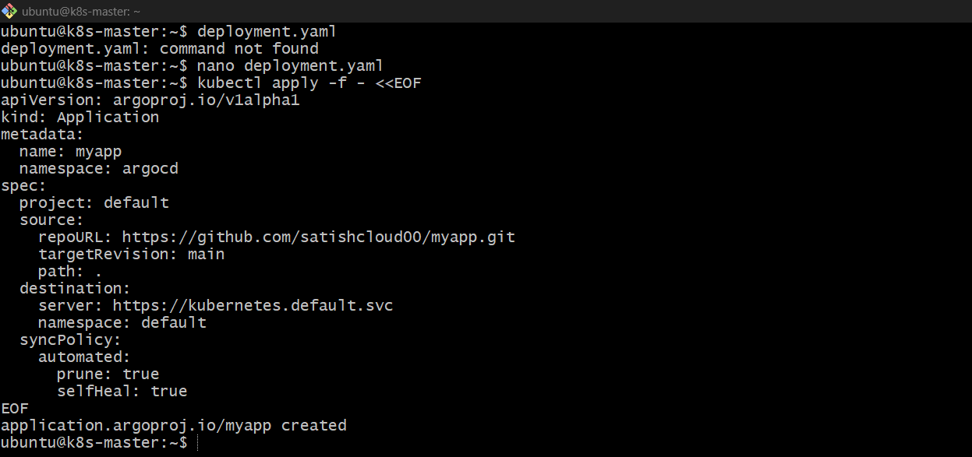

Step 3: Check Argo CD Application
kubectl get applications -n argocd
Expected:
myapp Synced Healthy 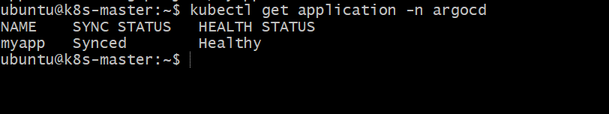

Step 4: Check EKS Deployment
kubectl get pods
You should see:
115034
myapp-xxxxx 1/1 Running
myapp-xxxxx 1/1 Running 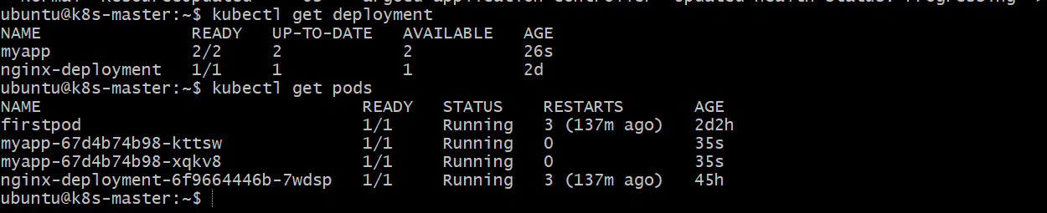
Final CI/CD Flow
Developer
↓
GitHub
↓
Jenkins
↓
Docker Image
↓
Git Kubernetes YAML
↓
Argo CD
↓
EKS

